

Compensation and Pension Record Interchange (CAPRI)

(CAPRI GUI v. DVBA_27_192_01)

Release Notes

Patch DVBA*2.7*192

September 2015

Department of Veterans Affairs

Office of Enterprise Development

Preface

Purpose of the Release Notes

The Release Notes document describes the enhancements and/or defects addressed in Patch DVBA*2.7*192.

Reference Numbering System

This document uses a numbering system to organize its topics into sections and show the reader how these topics relate to each other. For example, section 1.3 means this is the main topic for the third section of Chapter 1. If there were two subsections to this topic, they would be numbered 1.3.1 and 1.3.2. A section numbered 2.3.5.4.7 would be the seventh subsection of the fourth subsection of the fifth subsection of the third topic of Chapter 2. This numbering system tool allows the reader to more easily follow the logic of sections that contain several subsections.

Table of Contents

1 Overview 1

2 Customer – Veterans Health Administration (VHA) 1

2.1 Enhancements 1

2.1.1 Provide retransmit capabilities when transmission to Virtual VA (VVA) fails – Virtual VA Transmission Status screen 1

2.1.2 Modifications to CAPRI Contract Referral (CCR) functionality 2

2.1.3 Disable AMIS 290 and AMIS 290 by Division Reports in CAPRI and AMIE 7

2.1.4 Update 4 reports to capture the “Claim Type” and associated “Special Consideration(s)” fields – File|Reports menu 8

3 Customer – Veterans Health Administration (VHA) and Veterans Benefits Administration (VBA) 13

3.1 Enhancements 13

3.1.1 Provide ability to reorder exam request dates from newest to oldest – C&P Exams tab 13

4 Customer – Veterans Benefits Administration (VBA) 14

4.1 Enhancements 14

4.1.1 Remove obsolete references in the Exam Request Template – C&P Exams tab|Add a New Request|Exam Request Template 14

4.1.2 Allow VBA users to review and print VHA completed Compensation & Pension examination reports regardless of the requesting office. Notification message that currently displays “Those results do not belong to your office.” – C&P Exams Tab|Re-print final C&P Results button 17

5 Customer – Veterans Health Administration (VHA) and Veterans Benefits Administration (VBA) 17

5.1 Defects 17

5.1.1 Remedy ticket - INC000001008110 - CAPRI - Other: Des Moines insufficient exam error (Duplicate: INC000001303460) 17

5.1.2 Remedy ticket - INC000001249163 - The "Cytology" or "Surgical Path" report – DoD tab 17

5.1.3 Remedy ticket - INC000001305051 - CAPRI patch 190 has apparently broken the mouse scroll wheel (Duplicate: INC000001302423) 18

6 Software and Documentation Retrieval 19

6.1 VistA Patch DVBA*2.7*192 19

6.2 CAPRI GUI v192 Client Software & User Documentation 19

6.3 Related Documents 20

# Overview

The main purpose of this patch is to release a new version of the Compensation & Pension Record Interchange (CAPRI) Graphical User Interface (GUI) that includes defect fixes and enhancements to the user interface to support user interface modifications.

CAPRI GUI v192 and patch (DVBA*2.7*192) provide defect fixes and enhancements for the CAPRI GUI and the Automated Medical Information Exchange (AMIE) package.

The information contained in this document is not intended to replace the CAPRI GUI User Manual. The software defects and enhancements are briefly discussed so that readers are aware of high level functional changes. The CAPRI GUI User Manual should be used to obtain detailed information regarding specific functionality.

# Customer – Veterans Health Administration (VHA)

## Enhancements

### Provide retransmit capabilities when transmission to Virtual VA (VVA) fails – Virtual VA Transmission Status screen

When transmission fails to Virtual VA (VVA), either during auto-transmission, manual transmission (**Transmit to Virtual VA**), or via Report Builder (**Send to Virtual VA**), the user will now have the ability to retransmit using the “**Retransmit**” button.

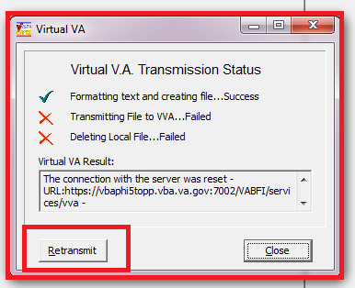

**\*\*Please Note:** The “**Retransmit**” button is only available when the transmission fails; otherwise, this button will not be displayed.

### Modifications to CAPRI Contract Referral (CCR) functionality

1. CAPRI CCR has been modified to no longer display **Email Address** on the “Contractor Editor Screen”. This screen is accessible from **Tools|CAPRI Contract Referral (CCR) |Admin Tools|Add/Edit Contractors.**

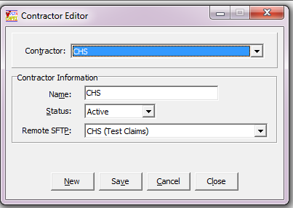

1. **CAPRI CCR** has been modified to **no longer** display the following fields on **CCR-C&P Exam Request Report Management screen.**

* STATUS:
* EXAM LOCATION:
* DATE OF EXAM:
* EXAMINING PROVIDER:

**Before**

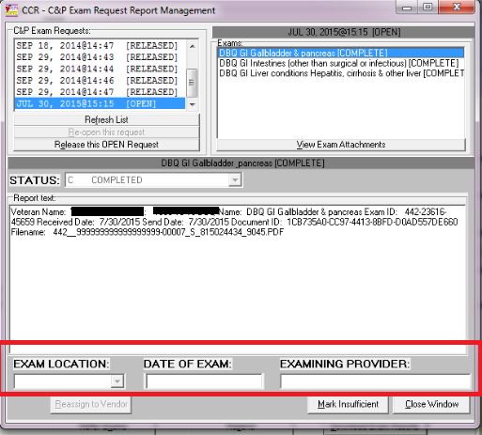

**After Patch 192 Installation**

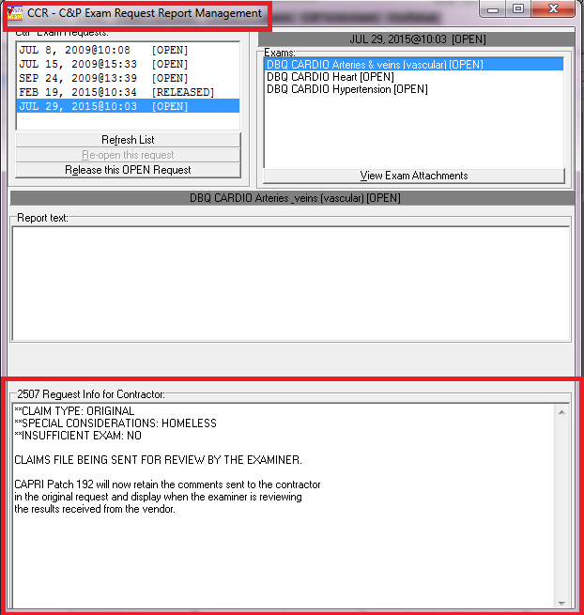

1. **CAPRI CCR** has been modified to display comments sent to a vendor in the original request on the **CCR-C&P Exam Request Report Management screen**.



**Please Note: “RESEND”** functionality in CCR does not maintain the comments originally sent to the vendor. If you need to resend the request and send the original comments again, you must copy those comments by accessing **CCR|Tools|Manage Patient’s C&P Exam Requests|CCR-C&P Exam Request Report Management screen (screen shown above)** and choose the exam to see the original comments.

1. Update messages on the CAPRI Alerts screen for DAS Enabled Vendors from “**You have # vendor exam requests pending review**” to “**You have # vendor exam requests ready for download.”** If no exam requests are ready for download, the message has been changed from **“You have no vendor exam request pending review” to “You have no vendor exam requests ready for download.”**

**New message when exam requests are available:**

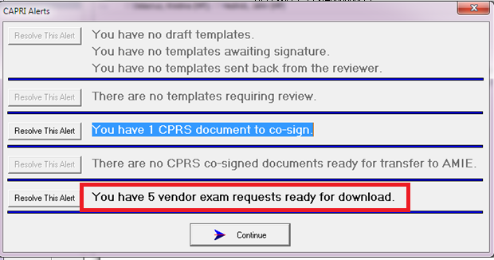

**New message when “no” exam requests are available:**

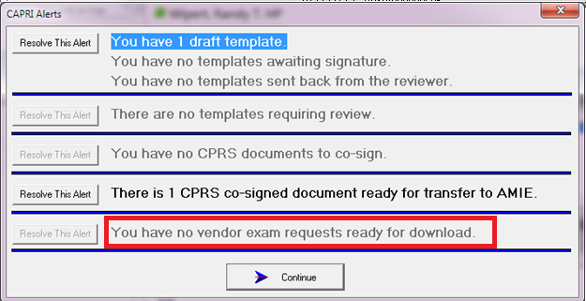

1. Update message displayed in the CAPRI CCR screen after the user has clicked “Download Exam Results” button from “**Vendor(s) Exam Results have been processed for this** **patient”** to **“Vendor Exam Results have been downloaded for this patient**”**.**

**New message when results have been downloaded for the patient:**

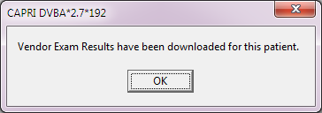

### Disable AMIS 290 and AMIS 290 by Division Reports in CAPRI and AMIE

AMIS 290 and AMIS 290 by Division reports will no longer be available in CAPRI or AMIE. The user will be directed to the following URL: <http://vaww.demo.va.gov/dmareports.asp>

**CAPRI messages:**

**AMIS 290**

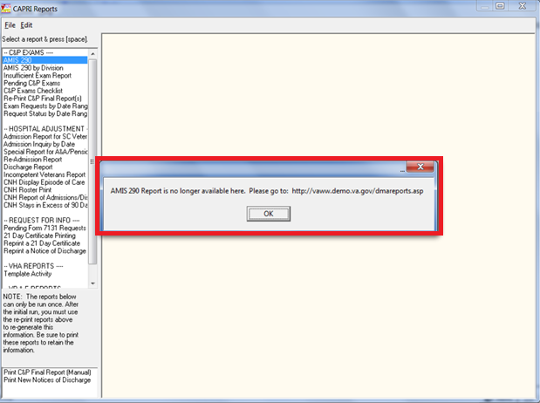

**AMIS 290 by Division**

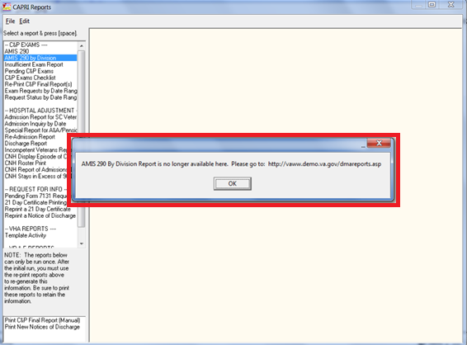

**AMIE Messages:**

**Option: DVBA C AMIS REPORT** AMIS 290 Report for C&P

AMIS 290 Report for C&P

The AMIS 290 Report is no longer available here.

**Please go to:** [**http://vaww.demo.va.gov/dmareports.asp**](http://vaww.demo.va.gov/dmareports.asp)

**Option: DVBA C RO AMIS 290 AMIS 290 for the Regional Office**

AMIS 290 for the Regional Office

The AMIS 290 Regional Office Report is no longer available here.

**Please go to:** [**http://vaww.demo.va.gov/dmareports.asp**](http://vaww.demo.va.gov/dmareports.asp)

### Update 4 reports to capture the “Claim Type” and associated “Special Consideration(s)” fields – File|Reports menu

The following 4 reports have been modified in CAPRI to capture and display the Claim Type and all associated Special Consideration(s) fields from C&P Exam request. Both plain text and excel components have been modified.

* **Pending C&P Exams**
* **Exam Requests by Date Range**
* **Request Status by Date Range**
* **Insufficient Exam Report**

**From the FILE|Reports menu:**

**Pending C&P Exams** (Plain text output)

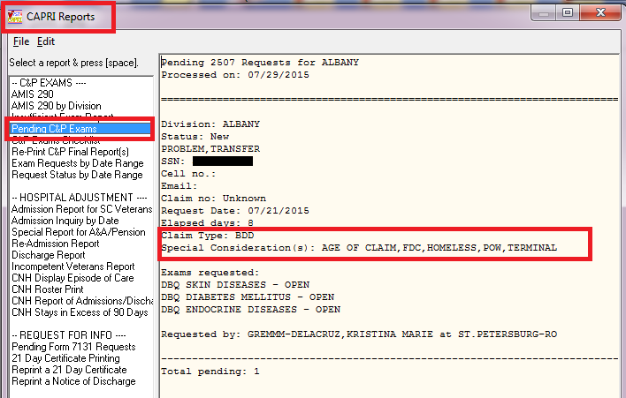

**Pending C&P Exams** (Excel output)

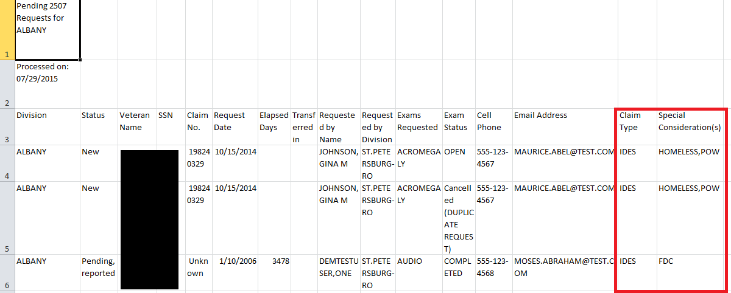

**Exam Request by Date Range:** (Plain text output)

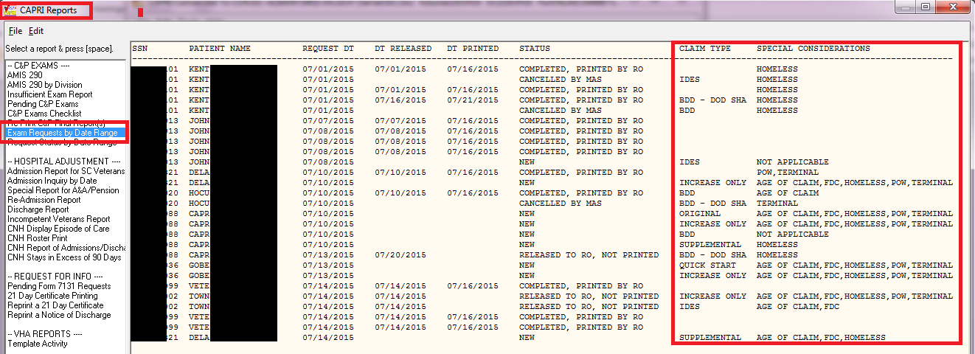

**Exam Request by Date Range: (**Excel output)



**Request Status by Date Range:** (Plain text output)

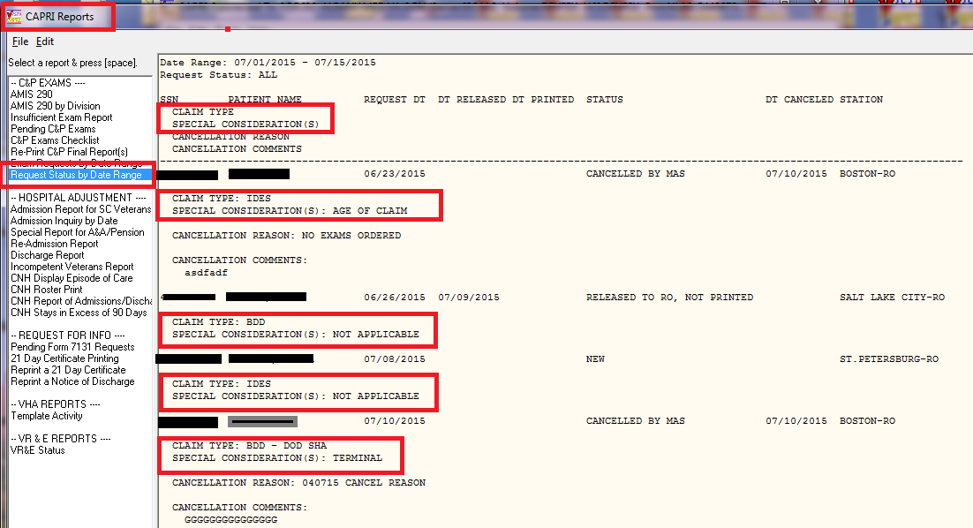

**Request Status by Date Range: (**Excel output)

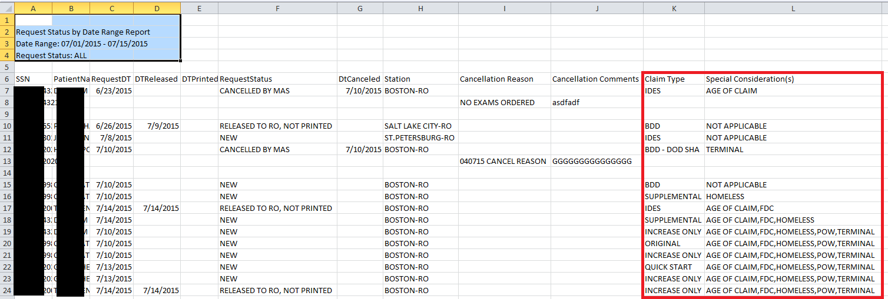

**Insufficient Exam Report:**

**\*\*NOTE**:** Insufficient Exam report has been modified not only to include “**Claim Type and Special Consideration(s)”,** but also to display historical data that contained “**Priority of Exam**”. This report will “**no longer**” filter from “**Priority of exam**” or “**Summary”**. This report will only be filtered by date range selected.

New screen **without** priority of exam or summary filters:

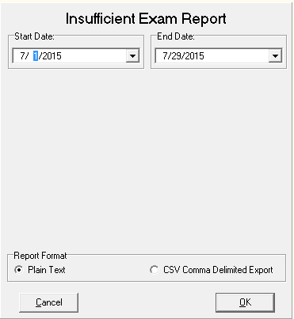

**Insufficient Exam Report** (Plain text output):

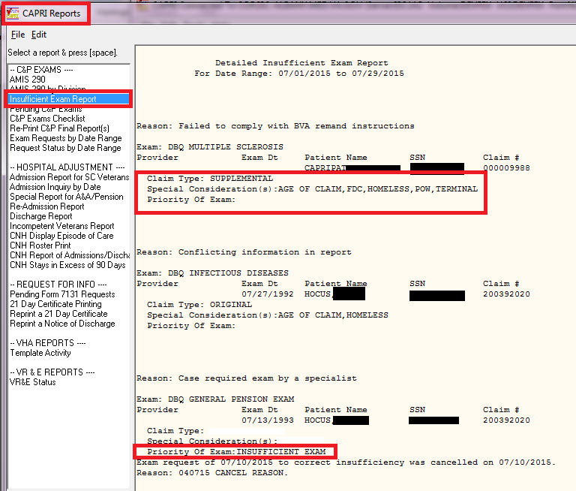

**Insufficient Exam Report** (Excel output**):**

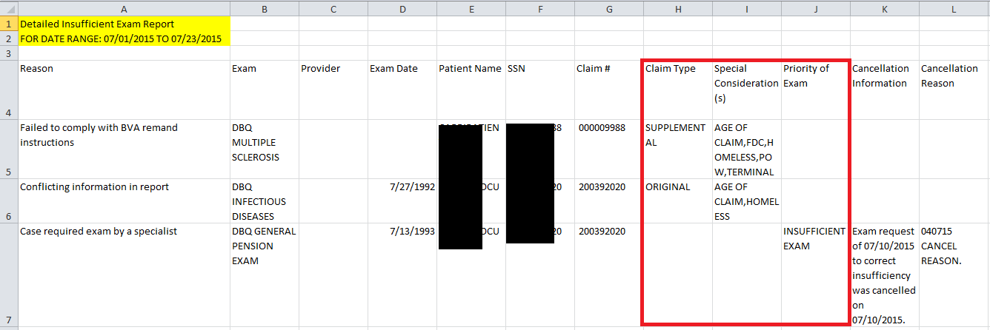

# Customer – Veterans Health Administration (VHA) and Veterans Benefits Administration (VBA)

## Enhancements

### Provide ability to reorder exam request dates from newest to oldest – C&P Exams tab

The C&P Exams tab has been modified to provide the user with the ability to sort the exam request dates from oldest to newest or newest to oldest. The default sort order is **Ascending**, which is oldest to newest.

**C&P Exams tab: (Default sort: Ascending)**

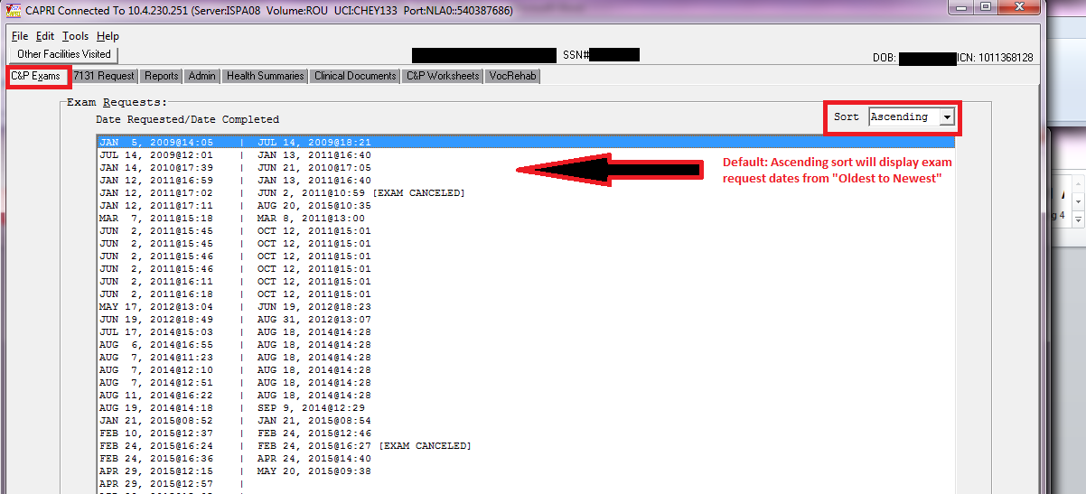

**C&P Exams tab: (Sort changed to Descending)**

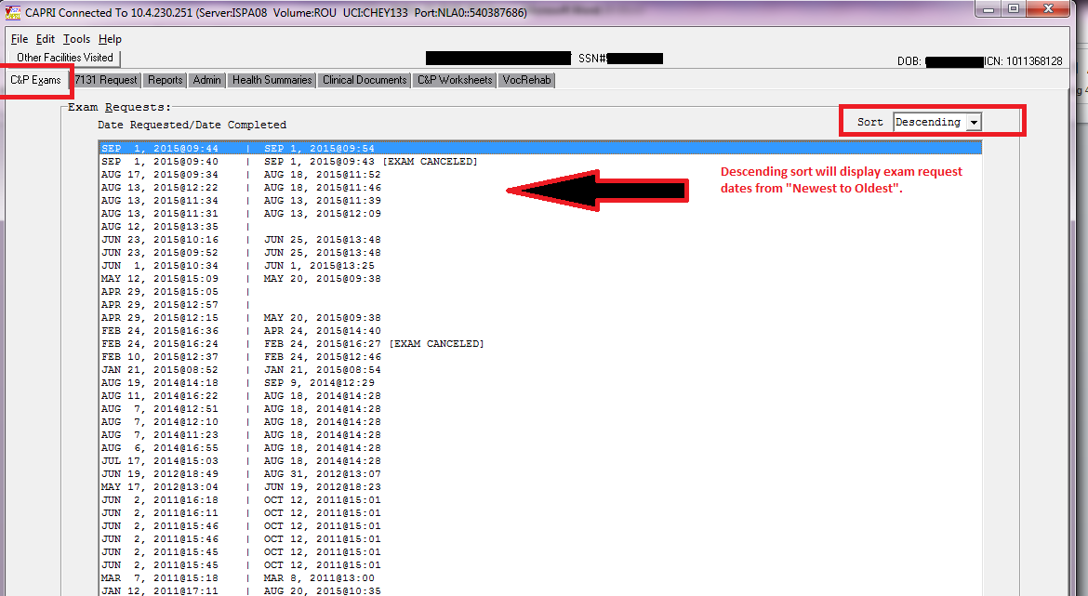

# Customer – Veterans Benefits Administration (VBA)

## Enhancements

### Remove obsolete references in the Exam Request Template – C&P Exams tab|Add a New Request|Exam Request Template

CAPRI has been modified to no longer display the following references when viewing the Exam Request Template.

1. All references to M21-1MR

2. All references to 38CFR

3. Any procedure notes

**Info tab before:**

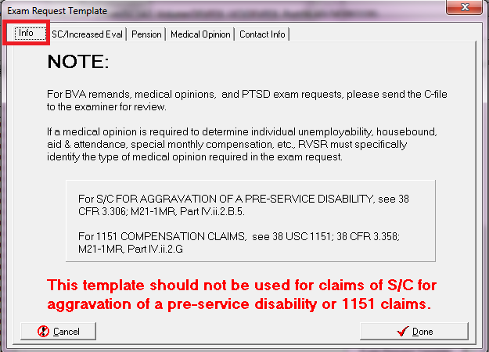

**Info tab after patch 192 installation no longer contains obsolete references**

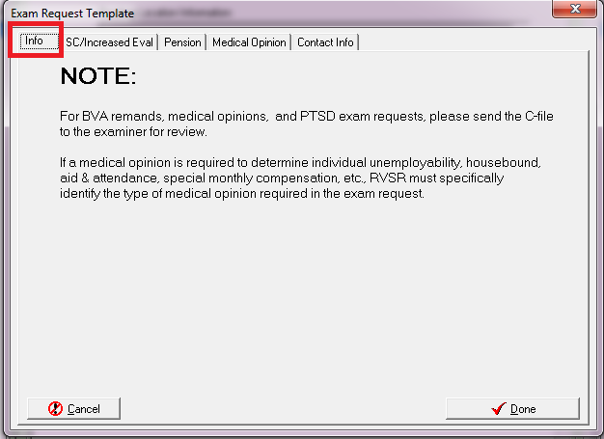

**Medical Opinion tab before**

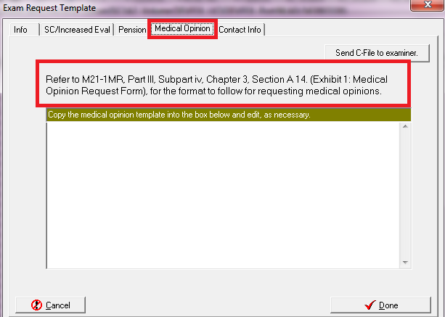

**Info tab after patch 192 installation no longer contains obsolete references**

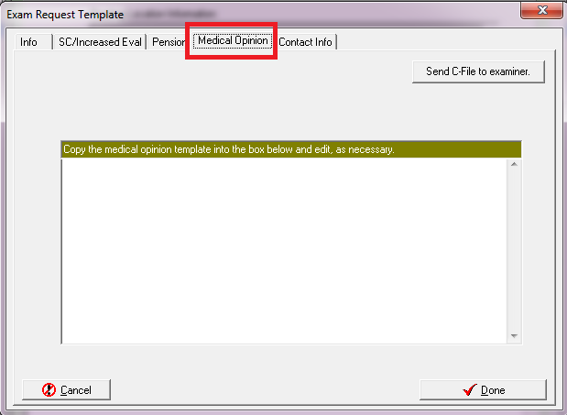

### Allow VBA users to review and print VHA completed Compensation & Pension examination reports regardless of the requesting office. Notification message that currently displays “Those results do not belong to your office.” – C&P Exams Tab|Re-print final C&P Results button

VBA users will now be able to Re-print final C&P Results for the following:

* Regardless of the “Requesting Office”. The message “**Those results do not belong to your office**” will no longer be displayed and the report will print.
* Whether the C&P Exam request has a status of **Released to RO, Not Printed** or **Completed, Printed by RO**.
* Regardless if the user has the following security key: **DVBA C SUPERVISOR**

# Customer – Veterans Health Administration (VHA) and Veterans Benefits Administration (VBA)

## Defects

### Remedy ticket - INC000001008110 - CAPRI - Other: Des Moines insufficient exam error (Duplicate: INC000001303460)

**Problem:**

While running the Detailed Insufficient Exam report in CAPRI, if the first record identified in the specified data range has an original 2507 EXAM (#396.4) record without a DATE OF EXAM (#.06), the current logic fails to set the variable DVBADTE which is used to display the

date in an external format leading to an undefined error.

**Solution:**

The Insufficient Exam report has been modified as follows and will no longer display an error. Prior to displaying the report, the code will verify the DVBADTE set and instances where it is not, it will be set to null which essentially displays a blank for that value rather than resulting in

an undefined error.

### Remedy ticket - INC000001249163 - The "Cytology" or "Surgical Path" report – DoD tab

**Problem:**

While running the "Cytology" or "Surgical Path" report from the **DoD tab**, if the date range for the report produces more than two records, selecting the third record or below will cause CAPRI to go into an endless loop and freeze.

**Solution:**

CAPRI has modified the record parsing logic so it will no longer go into an endless loop and freeze when the date range produces more than two records. All Cytology and Surgical Path records will be displayed and accessible.

### Remedy ticket - INC000001305051 - CAPRI patch 190 has apparently broken the mouse scroll wheel (Duplicate: INC000001302423)

**Problem:**

CAPRI patch 190 broke the usage of the mouse scroll wheel in the Exam Details, “**Exam Results**” window.

**Solution:**

CAPRI has been modified to allow the usage of the mouse scroll wheel in the “**Exam Results**” window instead of the “**Exam Details**” window.

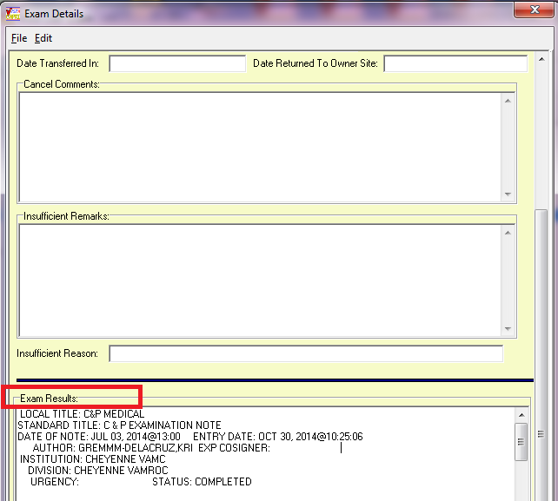

# Software and Documentation Retrieval

## VistA Patch DVBA*2.7*192

The VistA server software is being distributed as a PackMan patch message through the National Patch Module (NPM). The KIDS build for this patch is DVBA*2.7*192.

## CAPRI GUI v192 Client Software & User Documentation

The CAPRI GUI v192 client software is being distributed as executable CAPRI.exe contained in the zip file [**DVBA_27_P192_02.ZIP**]. The installed executable for this patch is client version 192.02 with a size of 16.4 MB.

The CAPRI GUI v192 client software and documentation for this patch may be retrieved directly using FTP. The preferred method is to FTP the files from:

download.vista.med.va.gov

This transmits the files from the first available FTP server. Sites may also elect to retrieve software directly from a specific server as follows:

|  |  |  |
| --- | --- | --- |
| OI&T Field Office | FTP Address | Directory |
| Albany | [ftp.fo-albany.med.va.gov](ftp://ftp.fo-albany.med.va.gov) | [anonymous.software] |
| Hines | [ftp.fo-hines.med.va.gov](ftp://ftp.fo-hines.med.va.gov) | [anonymous.software] |
| Salt Lake City | [ftp.fo-slc.med.va.gov](ftp://ftp.fo-slc.med.va.gov) | [anonymous.software] |

The following files will be available:

|  |  |  |
| --- | --- | --- |
| File Name | Retrieval Format | Contents |
| DVBA_27_P192_02.zip | Binary | File(s) indented below:   * CAPRI.exe - CAPRI v192 executable * VACAPRIVVA.dll – Virtual VA dynamically linked library * CAPRI_Help.chm * CAPRI.map - CAPRI error map * CAPRISession.r2w - Reflections session configuration * ssh_config - Secure Shell configuration * CAPRI_GUI_ISG.doc - CAPRI GUI Installation Supplemental Guide * Libeay32.dll - VLER /DAS dynamically linked library * Ssleay32.dll - VLER /DAS dynamically linked library * QPDF.exe – Support PDF compression and Linearization * QPDF13.dll – Support PDF compression and Linearization * LILBGCC_S_DW2-1.dll - Support PDF compression and Linearization * LIBSTCD++6.dll - Support PDF compression and Linearization |
| DVBA_27_P192_RN.PDF | Binary | Patch Release Notes (This document) |
| DVBA_27_P192_UM.PDF | Binary | Updated CAPRI GUI User Manual |
| CAPRI_SYSADMINTECH GUIDE_DVBA_27_TM.PDF | Binary | Updated CAPRI System Administration  And Technical Guide |

## Related Documents

The VA (Software) Documentation Library (VDL) web site will also contain the DVBA*2.7*192 Release Notes and updated CAPRI GUI User Manual. This website is usually updated within 1-3 days of the patch release date.

The VDL web address for CAPRI documentation is: <http://www.va.gov/vdl/application.asp?appid=133>